xA. AΔB= {{1}, 1, 2}

BΔC={2}

A⋂(B⋃C)={{2}}

(A⋂B)\C=∅

B.

(i) true

(ii) false

(iii) true

(iv) false

(v) false

C.

(i) R={<a,a>,<b,b>,<c,c>,<d,d>,<a,c>} cba to draw the directed graph on the computer.

(ii) 2^(n^2) relations on a set with n elements. 2^(n^2-n) reflexive relations.

Explanation: Take the matrix that represents a relation. It has n^2 entries with can have two values each. For reflexive relations we don’t consider the n entries on the diagonal.

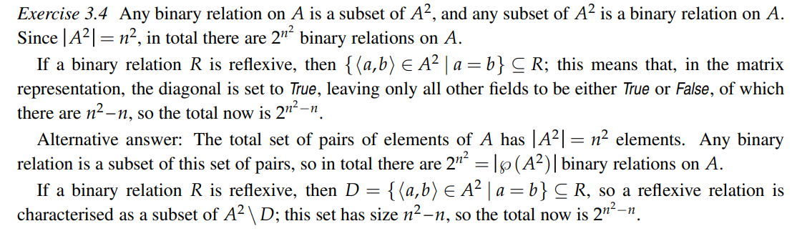

D.

1) Let x R--1 y, then yRx; since R ⊆ S, also ySx, and therefore x S--1 y; so R--1 ⊆ S--1.



2) x (R ∩ S)--1 y iff y R ∩ S x iff yRx ∧ ySx iff x R--1 y ∧ x S--1 y iff x R--1 ∩ S--1 y.

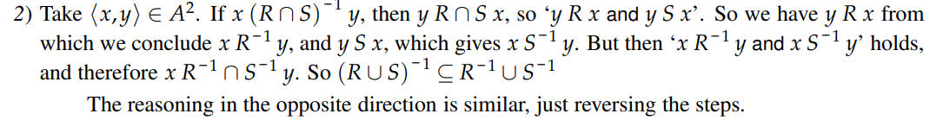

3) x (R)--1 y iff y R x iff ¬yRx iff ¬x R--1 y iff x R--1 y

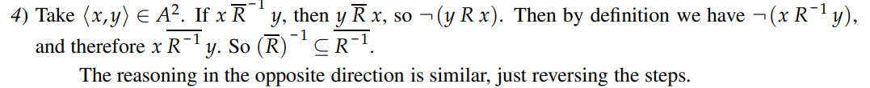

4) x (R◦S)--1 y iff y R◦ S x iff ∃z (yRz ∧ zSx) iff ∃z ( z R--1 y ∧ x S--1 z ) iff x S--1 ◦R--1 y.

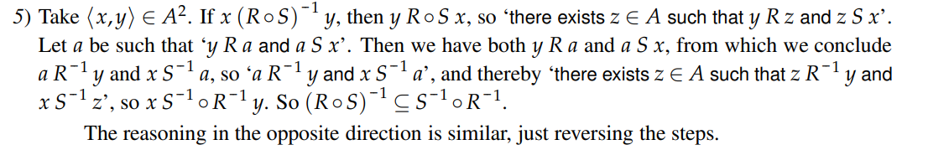

5) Take arbitrary xRy and yRz, then as R is symmetric, yRx and zRy.

The ‘n <x,x>,<y,y>,<z,z>,<x,z>,<z,x> ∈ R◦R. All pairs have symmetric counterpart, then R◦R symmetric.

Alt 5) Take arb a R◦R b

a R◦R b iff ∃c[aRc ^ cRb] iff ∃c[cRa ^ bRc] (by symmetry of R) iff b R◦R a

Therefore R◦R symmetric.

E. exercise 40

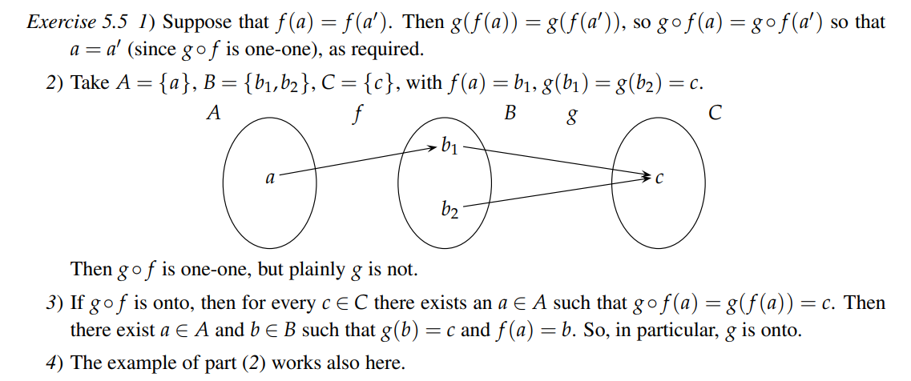

Where’s e?



*Graphs and Algorithms*

2) a. 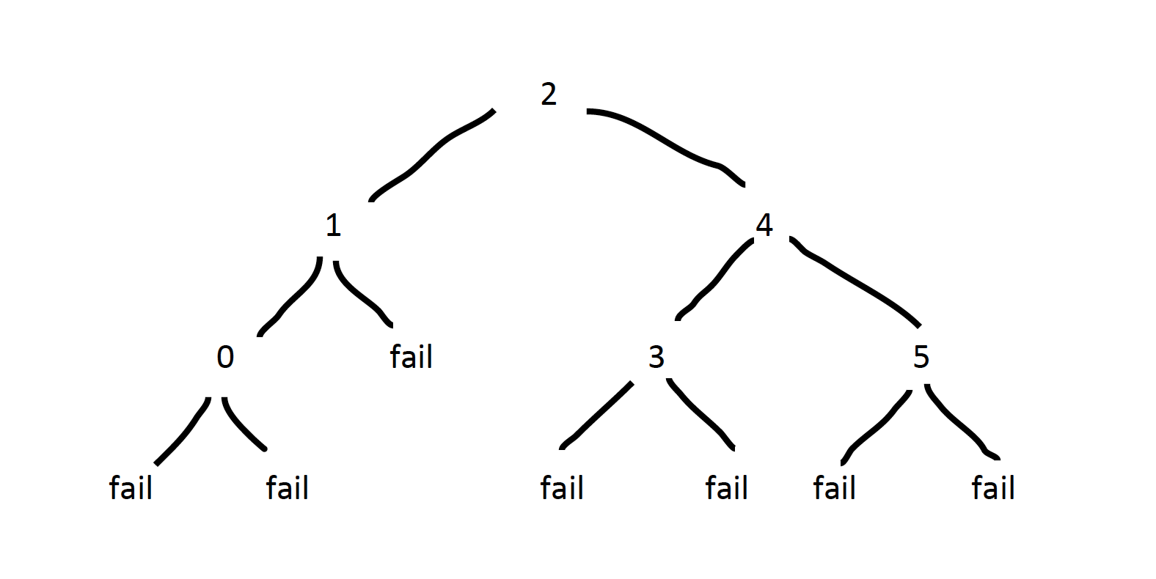

Worst-case number of comparisons = 3

b. (i) W(n) = n(n-1)/2

In the worst case, we need to perform 1 + 2 +...+ (n-1) comparisons. This gives n(n-1)/2   
**Shrimat Kapoor**

Shouldn't the 0 be at the top of the subtree (instead of the 1) and 1 be to the right? Because you are taking the floor of left + right

by the formula for the sum of k integers from 1 to k.

(ii) *(not sure if this is right)*

W(1) = 0

W(2) = 1

W(n) = 3(n-2) (for n > 2)

c. (i) W(1) = 0

W(n) = n - 1 + W(floor(n/2)) + W(ceiling(n/2))

7

(ii) W’(1) = 0

W’(n) = 1 + W’(floor(n/2)) + W’(ceiling(n/2))

(iii) for a power of 2, floor(n/2) = ceiling(n/2) = n/2

∴ W’(n) = 1 + 2W’(n/2)

= 1 + 2(1 + 2W’(n/4))

= 1 + 2 + 4W’(n/4)

= 1 + 2 + 4(1 + 2W’(n/8))

= 1 + 2 + 4 +.... 2^k-1

This corresponds to a geometric series where a = 1, r = 2 and n’ (number of terms) = k

(calling this n’ so as not to confuse with the n given in the questions)

∴ W’(n) = a(r^n’ - 1)/r - 1 = 1(2^k - 1)/2 - 1 = 2^k - 1 = **n - 1**